High-Accuracy Date Fruit Classification Using MobileNetV2 with Grad-CAM

Prabhupada Samantaray
School of Computer Engineering
KIIT University
BBSR, Odisha
22052483@kiit.ac.in
Aradhana Behura
School of Computer Engineering
KIIT University
BBSR, Odisha
aradhana.behurafcs@kiit.ac.in

Abstract—The agricultural sector increasingly demands automated solutions for fruit sorting and quality assessment. Manual classification of date fruits remains time-consuming and prone to human error, particularly when dealing with varieties that share similar visual characteristics. This research presents an intelligent classification system built on MobileNetV2 architecture, designed to identify nine distinct date fruit varieties with high accuracy. Working with a dataset of 1,658 carefully curated images captured under standardized conditions, we implemented a two-stage training approach combining transfer learning with fine-tuning optimization. Our model demonstrated impressive performance metrics on the test set: 95.18% accuracy, coupled with precision and recall scores exceeding 95%. The system's compact footprint of 24.7 MB and rapid inference time of approximately 96 milliseconds per image make it particularly well-suited for deployment in resource-constrained environments, including mobile devices and edge computing platforms. These characteristics position our solution as a practical tool for modernizing agricultural operations.
Index Terms—Convolutional Neural Networks, Agricultural Technology, Computer Vision, Fruit Recognition, Mobile Deployment, Transfer Learning

I. INTRODUCTION
Date palms have been cultivated for thousands of years, and their fruits remain a dietary staple across Middle Eastern, African, and South Asian regions. As global demand continues to rise, the agricultural industry faces mounting pressure to streamline sorting and grading processes that have traditionally relied on manual inspection. Human evaluators must distinguish between varieties based on subtle differences in color, texture, and shape—a task that becomes increasingly challenging at industrial scales where consistency and speed are paramount.
Recent breakthroughs in computer vision and deep learning have opened new possibilities for agricultural automation. Convolutional neural networks have proven remarkably effective at recognizing patterns in visual data, often surpassing human-level performance in image classification tasks. However, many state-of-the-art models demand substantial computational resources, making them impractical for deployment in field conditions or on mobile devices.
This research addresses the need for an accurate yet lightweight classification system by leveraging MobileNetV2, an architecture specifically engineered for efficiency. Our objective was to develop a practical solution capable of distinguishing nine common date varieties with both high accuracy and fast processing speeds. Through careful dataset preparation, strategic use of transfer learning, and methodical fine-tuning, we created a model that balances performance with deployability.
The significance of this work extends beyond academic interest. A reliable, portable classification system could transform how date fruits are processed, enabling real-time quality control, reducing labor costs, and improving consistency in agricultural operations. Our results demonstrate that sophisticated AI capabilities can be packaged into compact, accessible formats suitable for widespread adoption in the agricultural sector.

II. LITERATURE REVIEW
The application of machine learning to fruit classification has evolved significantly over the past two decades. Early approaches relied heavily on traditional computer vision techniques, extracting handcrafted features such as color histograms, texture descriptors, and geometric properties. Researchers employed algorithms like Support Vector Machines and Random Forests to classify fruits based on these manually engineered features. While these methods showed promise in controlled laboratory settings, they struggled to maintain performance when confronted with natural lighting variations, different camera angles, or diverse environmental conditions.
The emergence of deep learning fundamentally changed this landscape. Convolutional neural networks eliminated the need for manual feature engineering by automatically learning hierarchical representations from raw image data. Architectures such as VGG, ResNet, and Inception networks achieved remarkable results in fruit quality assessment and variety classification. These models demonstrated that given sufficient training data, neural networks could capture subtle visual patterns that even experienced human inspectors might miss.
However, the computational demands of these deep networks presented a significant obstacle to practical deployment. Models with hundreds of millions of parameters required powerful GPUs for inference, making them unsuitable for mobile applications or edge devices commonly found in agricultural settings. This limitation sparked interest in efficient architecture design.
MobileNet architectures emerged as a response to this efficiency challenge. The original MobileNetV1 introduced depthwise separable convolutions to dramatically reduce computational costs while maintaining competitive accuracy. MobileNetV2 built upon this foundation with inverted residual structures and linear bottlenecks, achieving an even better balance between model size and performance. These innovations made it feasible to deploy sophisticated classification models on smartphones and embedded systems.
Recent studies have explored various lightweight architectures for agricultural applications, including EfficientNet and SqueezeNet variants. While each offers unique advantages, MobileNetV2 has consistently demonstrated robust performance across diverse image classification tasks, making it an excellent foundation for specialized applications like date fruit recognition. Our work contributes to this growing body of research by demonstrating how transfer learning and careful fine-tuning can adapt MobileNetV2 to achieve high accuracy on a specific agricultural classification challenge.

III. PROPOSED METHODOLOGY
Our classification pipeline was designed with both accuracy and practical deployability in mind. The development process encompassed five interconnected stages: dataset acquisition and preparation, image preprocessing, model architecture design, training strategy implementation, and comprehensive performance evaluation.

Dataset Characteristics
We utilized the Date Fruit Image Dataset compiled by Wadhasnalhamdan and made available through Kaggle. This collection consists of 1,658 high-quality images captured in controlled lighting and background conditions, ensuring visual consistency that facilitates effective learning. The dataset encompasses nine distinct date varieties commonly found in commercial production:
- Ajwa: Dark, almost black fruits with a distinctive wrinkled texture
- Galaxy: Medium-sized dates with characteristic surface patterns
- Medjool: Large, amber-colored fruits prized for their sweetness
- Meneifi: Elongated variety with smooth skin
- Nabtat Ali: Medium-sized with unique coloration
- Rutab: Semi-ripe dates with softer texture
- Shaishe: Small to medium fruits with specific visual markers
- Sokari: Golden-yellow dates with firm texture
- Sugaey: Characterized by their particular shape and color profile
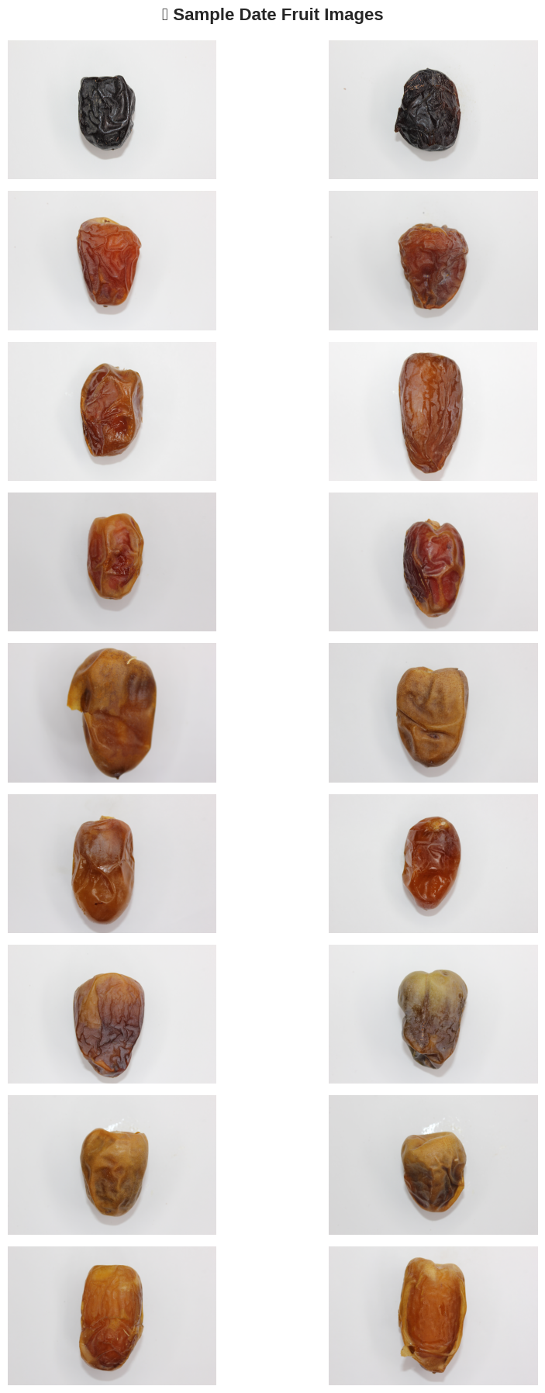
Fig. 1. Sample images representing different varieties in the Date Fruit dataset.
The dataset was partitioned using an 80-10-10 split strategy, yielding 1,326 images for training, 166 for validation during development, and 166 held out for final testing. This distribution ensured adequate learning examples while maintaining sufficient data for unbiased performance assessment.
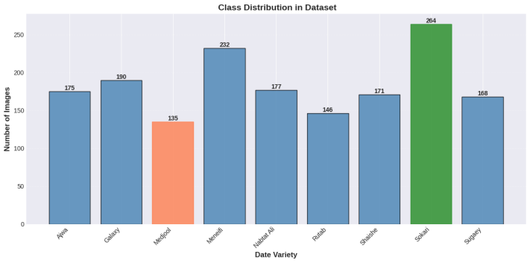
Fig. 2. Class distribution of the nine varieties in the Date Fruit dataset.

Preprocessing Pipeline
Standardization and augmentation formed the core of our preprocessing approach. Each image underwent resizing to 224×224 pixels to match MobileNetV2's expected input dimensions. Pixel values were normalized to the [0,1] range, converting raw 8-bit integer values to floating-point representations that facilitate gradient-based optimization.
To enhance the model's generalization capability despite the relatively modest dataset size, we implemented several augmentation techniques during training:
- Rotation: Random rotations within a reasonable angular range to simulate different fruit orientations
- Horizontal Flipping: Mirror images to double effective dataset size and remove directional bias
- Brightness Adjustment: Subtle variations to account for different lighting conditions
- Zoom Operations: Random zooming to help the model focus on relevant features regardless of scale
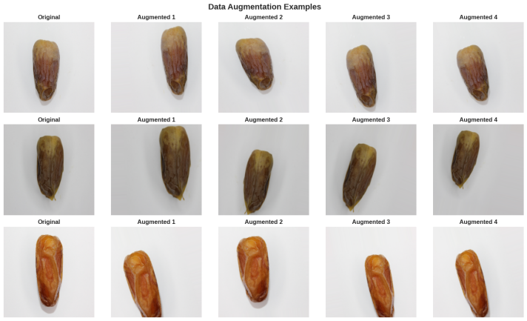
Fig. 3. Examples of data augmentation techniques applied during preprocessing.
These augmentations were applied on-the-fly during training, meaning each epoch exposed the model to slightly different versions of the training images, effectively expanding the diversity of training examples without actually collecting more data.

Model Architecture
Our architecture adopted a transfer learning approach, building upon MobileNetV2's proven feature extraction capabilities. The base model came pre-trained on ImageNet, a massive dataset containing millions of images across thousands of categories. This pre-training provided a strong foundation of low and mid-level feature detectors—edge detectors, texture recognizers, and shape identifiers—that transfer effectively to new visual tasks.
On top of this feature extraction base, we constructed a custom classification head tailored to our nine-class problem:
- Global Average Pooling: Reduces spatial dimensions while preserving learned features, converting feature maps into compact representations
- Dense Layer: A fully connected layer with ReLU activation, providing additional learning capacity to combine features in task-specific ways
- Dropout Regularization: Randomly deactivates neurons during training to prevent over-reliance on specific features and improve generalization
- Output Layer: Nine neurons with softmax activation, producing probability distributions across date varieties
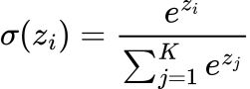
The complete architecture contains approximately 2.62 million trainable parameters, compiled into a model file of just 24.79 MB—small enough for mobile deployment while sufficiently expressive for accurate classification.

Training Strategy
We employed a staged training approach to maximize learning efficiency:
Stage 1: Classification Head Training
In this initial phase, we froze all MobileNetV2 base layers, allowing only the custom classification head to learn. This strategy makes sense because the ImageNet pre-trained features already capture useful visual patterns, and we primarily need to learn how to combine these features for date classification. Training parameters included:
- Duration: 10 epochs
- Learning Rate: 0.001 (relatively high for rapid initial learning)
- Optimizer: Adam with default momentum parameters
- Loss Function: Categorical cross-entropy
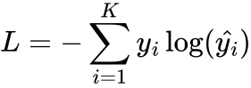
This stage achieved 94.58% validation accuracy, demonstrating that even with minimal adaptation, the pre-trained features provided strong discriminative power.
Stage 2: Fine-Tuning
After establishing a solid classification head, we unfroze the final 40 layers of the MobileNetV2 base, allowing these layers to adapt to date-specific visual patterns. Fine-tuning parameters included:
- Duration: 20 epochs
- Learning Rate: 1e-5 (much lower to make subtle adjustments without disrupting pre-trained features)
- Same optimizer and loss function as Stage 1
This careful fine-tuning pushed validation accuracy to 96.39%, showing that allowing deeper layers to specialize for our specific task yielded meaningful improvements.

Evaluation Framework
We assessed model performance using multiple complementary metrics to gain a complete picture of classification behavior:
- Accuracy: Overall percentage of correct predictions
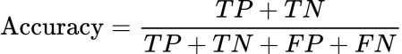
- Precision: Proportion of positive predictions that were actually correct (per class)
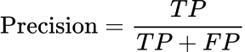
- Recall: Proportion of actual positives that were correctly identified (per class)
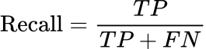
- F1-Score: Harmonic mean of precision and recall, providing a balanced performance measure
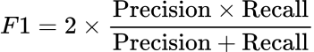
- Confusion Matrix: Visualization of prediction patterns showing which classes are confused with each other
- Inference Time: Average time required to classify a single image
These metrics collectively reveal not just how often the model is correct, but also where and why it makes mistakes—critical information for real-world deployment planning.
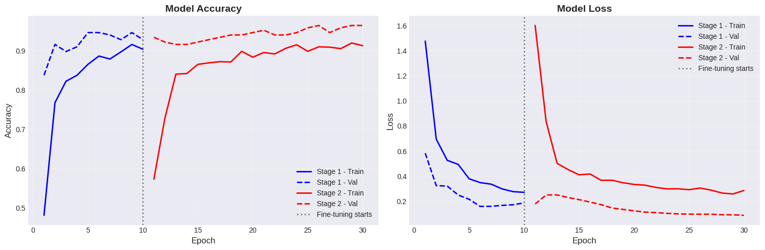
Fig. 4. Training and validation accuracy curve for Stage 1 and Stage 2.


Fig. 5. Training and validation loss curve for Stage 1 and Stage 2.

IV. RESULTS AND ANALYSIS
Our fine-tuned MobileNetV2 model demonstrated strong performance across all evaluation metrics, validating the effectiveness of our training strategy and architectural choices.

Overall Performance Metrics
Testing on the held-out test set of 166 images yielded the following results:
- Test Accuracy: 95.18%
- Precision: 95.68%
- Recall: 95.18%
- F1-Score: 95.21%
These closely aligned metrics indicate balanced performance across all date varieties, with no significant bias toward over-predicting or under-predicting any particular class. The high F1-score confirms that the model achieves both high precision (few false positives) and high recall (few false negatives)—crucial characteristics for practical deployment where both types of errors carry costs.
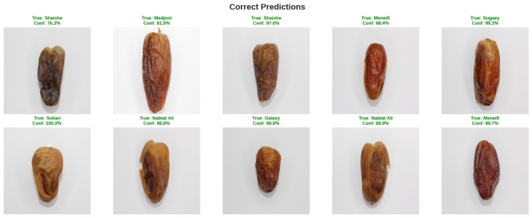
Fig. 6. Examples of correct predictions with confidence scores.

Computational Efficiency
Beyond accuracy, the model's computational characteristics make it particularly suitable for real-world applications:
- Inference Time: 96.68 milliseconds per image
- Throughput: Approximately 10.3 images per second
- Model Size: 24.79 MB
These specifications mean the model can process images in near real-time on modest hardware. The compact file size enables deployment on smartphones and edge devices without requiring cloud connectivity, an important consideration for agricultural settings where reliable internet access may be limited.

Error Analysis
Examination of the confusion matrix revealed interesting patterns in model behavior:
Strong Performance: The model showed exceptional accuracy on varieties with distinctive visual characteristics, particularly Ajwa (dark, wrinkled texture) and Medjool (large, amber appearance). For these classes, classification was nearly perfect with minimal confusion.
Occasional Confusion: The primary source of errors occurred between Rutab and Meneifi varieties, which share similar elongated shapes and can have overlapping color profiles, especially in semi-ripe states. This confusion mirrors the challenges human inspectors face with these varieties, suggesting the model has learned to focus on the same subtle distinguishing features that humans use.
Class Balance: Despite variations in the visual distinctiveness of different varieties, the model maintained consistently high performance across all nine classes, with no single variety showing dramatically worse results than others.
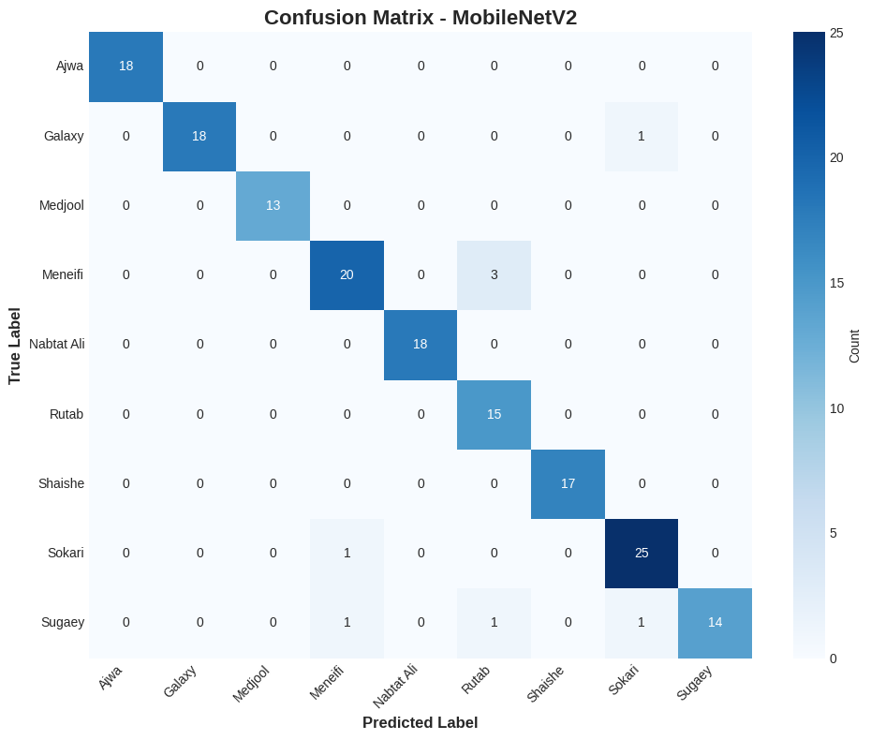
Fig. 7. Confusion matrix showing class-wise prediction accuracy of the MobileNetV2 model.
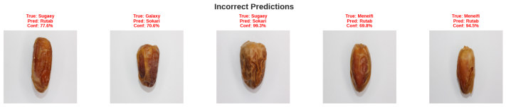
Fig. 8. Misclassified examples demonstrating visual similarity among certain date fruit varieties.

Training Dynamics
Throughout both training stages, the model demonstrated healthy learning curves without signs of overfitting. Validation accuracy improved steadily during Stage 1, then continued climbing during fine-tuning, while training and validation losses converged appropriately. The gap between training and validation performance remained small, indicating good generalization rather than mere memorization of training examples.
The staged approach proved valuable: Stage 1 quickly established baseline performance by learning task-specific classification patterns, while Stage 2's careful fine-tuning refined feature extraction to better capture date-specific visual characteristics.
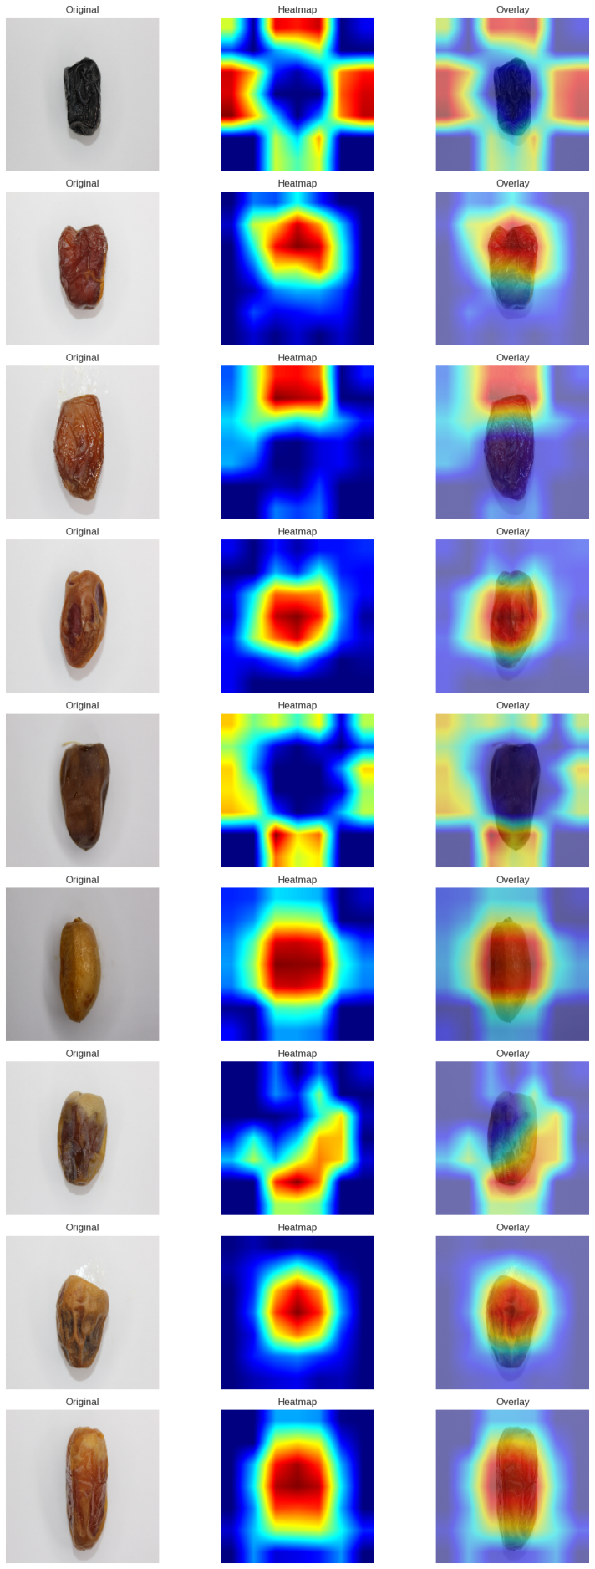
Fig. 9. Grad-CAM heatmaps showing discriminative regions used by the model for classification.

V. CONCLUSION AND FUTURE DIRECTIONS
This research successfully demonstrates that efficient deep learning architectures can deliver high-accuracy fruit classification suitable for practical agricultural applications. Our MobileNetV2-based system achieved 95.18% test accuracy while maintaining the compact size and fast inference speeds necessary for mobile and edge deployment.
The primary achievements of this work include:
- Proven Effectiveness: Validation that transfer learning from ImageNet provides an excellent foundation for specialized agricultural classification tasks
- Practical Architecture: Development of a balanced model that sacrifices neither accuracy nor efficiency
- Deployment Readiness: Creation of a system sized and optimized for real-world agricultural environments
- Comprehensive Evaluation: Thorough performance analysis that identifies both strengths and limitations
These contributions move beyond academic exercise toward genuinely useful technology that could be adopted in commercial date processing operations.
Several promising avenues exist for extending and improving this work:
Dataset Expansion: The current dataset's controlled-environment nature, while valuable for initial development, limits generalizability. Incorporating images captured under varying lighting conditions, backgrounds, and camera angles would strengthen robustness for field deployment.
Hardware Deployment: Testing the model on target platforms such as Raspberry Pi, NVIDIA Jetson Nano, or mobile devices would provide concrete performance benchmarks and identify any optimization needs for specific hardware.
Object Detection Integration: Expanding beyond classification to include fruit localization would enable fully automated sorting systems that can identify and physically separate different varieties.
Model Compression: Applying quantization techniques could reduce model size further, potentially enabling deployment on even more resource-constrained devices while maintaining acceptable accuracy.
User Interface Development: Creating an intuitive mobile application would make the technology accessible to individual farmers and small-scale operations, democratizing access to AI-powered classification tools.
Multi-Modal Learning: Incorporating additional data sources, such as near-infrared imaging or texture sensing, might improve discrimination between visually similar varieties.
The intersection of deep learning and agriculture holds tremendous potential for addressing global food production challenges. This project demonstrates that sophisticated AI capabilities need not require massive computational resources—carefully designed efficient architectures can deliver professional-grade performance in portable, affordable packages. As the technology matures and datasets grow, we anticipate seeing widespread adoption of AI-assisted fruit classification across various agricultural sectors, contributing to more efficient food production and improved product quality worldwide.

REFERENCES
- Albarrak, Khalied, et al. "A deep learning-based model for date fruit classification." Sustainability 14.10 (2022): 6339.
- Almomen, Mohammed, Majed Al-Saeed, and Hafiz Farooq Ahmad. "Date fruit classification based on surface quality using convolutional neural network models." Applied Sciences 13.13 (2023): 7821.
- Alsirhani, Amjad, et al. "A novel classification model of date fruit dataset using deep transfer learning." Electronics 12.3 (2023): 665.
- Koklu, Murat, et al. "Classification of date fruits into genetic varieties using image analysis." Mathematical Problems in Engineering 2021.1 (2021): 4793293.
- Altaheri, Hamdi, Mansour Alsulaiman, and Ghulam Muhammad. "Date fruit classification for robotic harvesting in a natural environment using deep learning." Ieee Access 7 (2019): 117115-117133.
- Eser, Murat, et al. "Using pretrained models in ensemble learning for date fruits multiclass classification." Journal of Food Science 90.3 (2025): e70136.
- Nasiri, Amin, Amin Taheri-Garavand, and Yu-Dong Zhang. "Image-based deep learning automated sorting of date fruit." Postharvest biology and technology 153 (2019): 133-141.
- Kamal-Eldin, Afaf, and Sami Ghnimi. "Classification of date fruit (Phoenix dactylifera, L.) based on chemometric analysis with multivariate approach." Journal of Food Measurement and Characterization 12.2 (2018): 1020-1027.
- Fahim, Sajid Faysal, et al. "MobileNetV2: A Proficient Convolutional Neural Network for the Classification of Date Fruits into Genetic Varieties." International Conference on Machine Learning Algorithms. Cham: Springer Nature Switzerland, 2024.
- Khalique, Abdul, et al. "CNN-Based Intelligent System for Date Fruit Classification using Novel Dataset." VFAST Transactions on Software Engineering 12.4 (2024): 134-144.
- Ikram, Kourtiche & Bendjima, Mostefa & Kourtiche, Mohammed El Amin. (2025). Date fruit classification using CNN and stacking model. Indonesian Journal of Electrical Engineering and Computer Science. 39. 1373.10.11591/ijeecs.v39.i2.pp1373-1383.
- Neji, Ines, et al. "DenseViT-XGB: A hybrid approach for dates varieties identification." Neurocomputing 596 (2024): 127976.
- Noutfia, Younés, and Ewa Ropelewska. "Innovative models built based on image textures using traditional machine learning algorithms for distinguishing different varieties of Moroccan date palm fruit (Phoenix dactylifera L.)." Agriculture 13.1 (2022): 26.
- Safran, Mejdl, Waleed Alrajhi, and Sultan Alfarhood. "DPXception: a lightweight CNN for image based date palm species classification." Frontiers in Plant Science 14 (2024): 1281724.
- Noutfia, Younés, and Ewa Ropelewska. "Comprehensive characterization of date palm fruit ‘Mejhoul’(Phoenix dactylifera L.) measurements." Agriculture 13.1 (2022): 74. using image analysis and quality attribute
- Altaheri, Hamdi, et al. "Date fruit dataset for intelligent harvesting." Data in brief 26 (2019): 104514.
- Faisal, Mohammed, et al. "IHDS: Intelligent harvesting decision system for date fruit based on maturity stage using deep learning and computer vision." IEEE Access 8 (2020): 167985-167997.
- Faisal, Mohammed, et al. "Deep learning and computer vision for estimating date fruits type, maturity level, and weight." IEEE Access 8 (2020): 206770-206782.
- Alresheedi, Khaled Marji, et al. "Dates Fruit Recognition: From Classical Fusion to Deep Learning." Computer Systems Science & Engineering 40.1 (2022).
- Ali, Jawad, Muhammad Ramzan, and Abid Rafiq. "DeepPalm: Deep Learning Classification Model for Date Palm Varieties." Journal of Computing & Biomedical Informatics (2024).
- Abi Sen, Adnan Ahmed, et al. "A classification algorithm for date fruits." 2020 7th International Conference on Computing for Sustainable Global Development (INDIACom). IEEE, 2020.
- Muhammad, Ghulam. "Automatic date fruit classification by using local texture descriptors and shape-size features." 2014 European Modelling Symposium. IEEE, 2014.
- Aiadi, Oussama, et al. "Date fruit sorting based on deep learning and discriminant correlation analysis." IEEE Access 10 (2022): 79655-79668.
- Al Ohali, Yousef. "Computer vision based date fruit grading system: Design and implementation." Journal of King Saud University-Computer and Information Sciences 23.1 (2011): 29 36.
- Hayat, Ahatsham, et al. "FruitVision: A deep learning based automatic fruit grading system." Open Agriculture 9.1 (2024): 20220276.
- Lee, Dah-Jye, et al. "Robust color space conversion and color distribution analysis techniques for date maturity evaluation." Journal of Food Engineering 88.3 (2008): 364-372.
- Hassan, Esraa, et al. "Sustainable deep vision systems for date fruit quality assessment using attention-enhanceddeeplearningmodels."FrontiersinPlantScience16(2025):1521508.
- Ma,Jie,etal."State-of-the-ArtTechniquesforFruitMaturityDetection."Agronomy14.12(2024)

